How to edit website:

Step1: Navigate to the bottom of the website and click on **edit**.



Step 2: Enter password on the prompt (pass:000), this password is not important, it just prevent people accidentally click it and mess with the website content on their end.

Step3: The best way to edit the content is to edit it in Microsoft Word and paste it to the website.

* Big heading: font: Source Serif Pro, size: 37.5
* Small heading: font: Source Serif Pro, size: 19
* Text: font: Calibri light, size: 12

The editing part on the website look like this. It covers with blue outline

In the first couple part of the page, the Small Heading and the Text are separated into different box. But from now on paste both in the same box but edit the font and the size first in Microsoft Word

Step4: After finished editing click **save** in the bottom of the page, it will download the .json file name **localStorageData_{name of the page you edited}.json**.

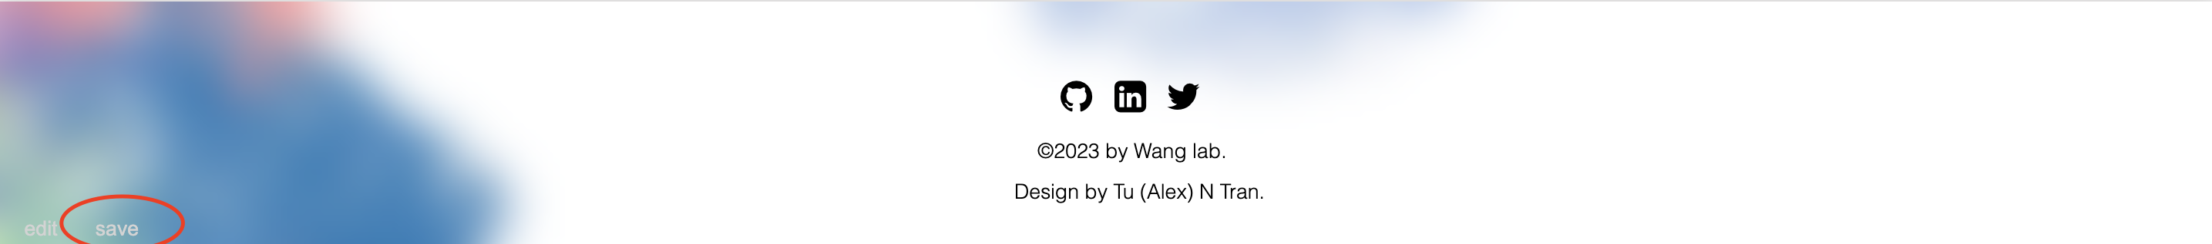

Upload this file in github folder located in **./js/json**.

It will take about 3 minutes after GitHub successfully upload the file for the content to be seen on the website. If you don’t upload the .json file on GitHub, the editing will be lost after you refreshing the website. Picture upload is not supported.